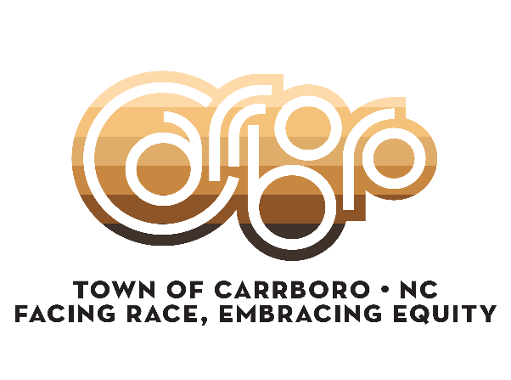
Racial Equity Commission Meeting Agenda
February 25, 2026 - 6:00 pm
108 Bim Street
6:00 p.m. Call the Meeting to Order
6:05 p.m. Introduction of Guests
6:10 p.m. Approval of January 2026 Meeting Minutes
6:15 p.m. REAL Review
Climate Action REAL – Amy Armbruster, Chief Sustainability Officer
6:30 p.m. Discussion
Truth Plaque for Rogers Road Community
Truth Plaque for Alderman Hilliard Caldwell (home street or MLK park)
Make-up of commission member seats
Tabling at Earth/Carrboro Day – Sunday, April 19th from 12 – 4p
7:30 p.m. Agenda items for next meeting
7:35 p.m. Updates and Announcements
7:40 p.m. Adjourn
TOWN HALL AND BIM STREET ARE ACCESSIBLE FOR PERSONS WITH DISABILITIES.
For more information, contact staff at 919.919.7381

